Appendix E: Forest Plot Exports
1.1 Match TL/1000AE
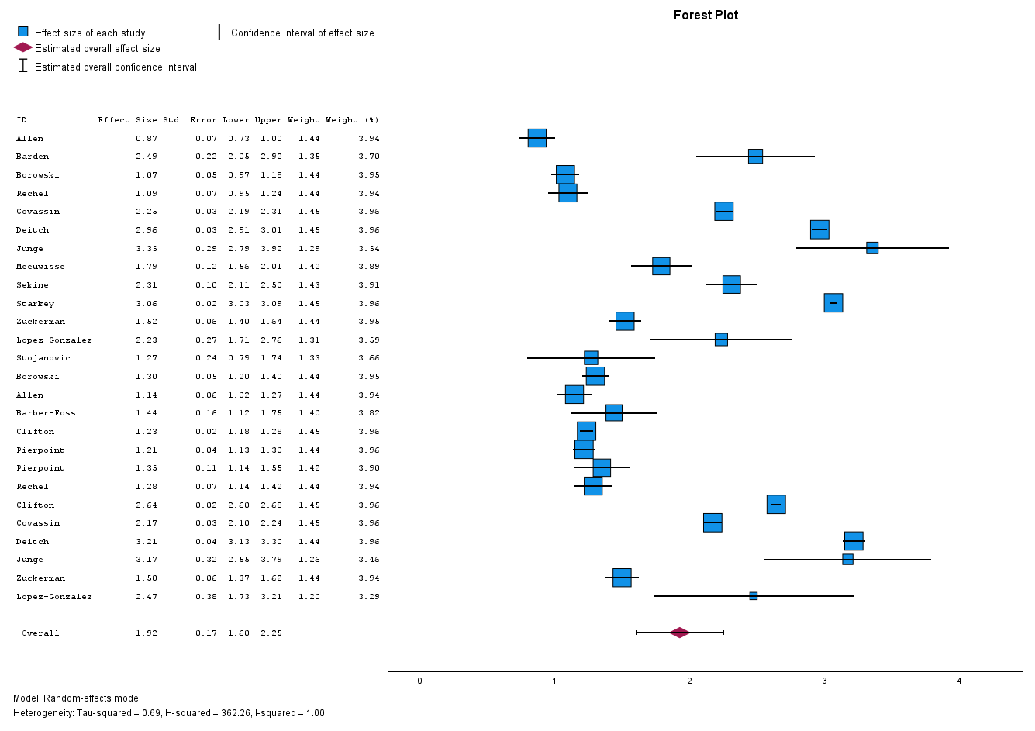
1.2 Sub-group: Playing-age group
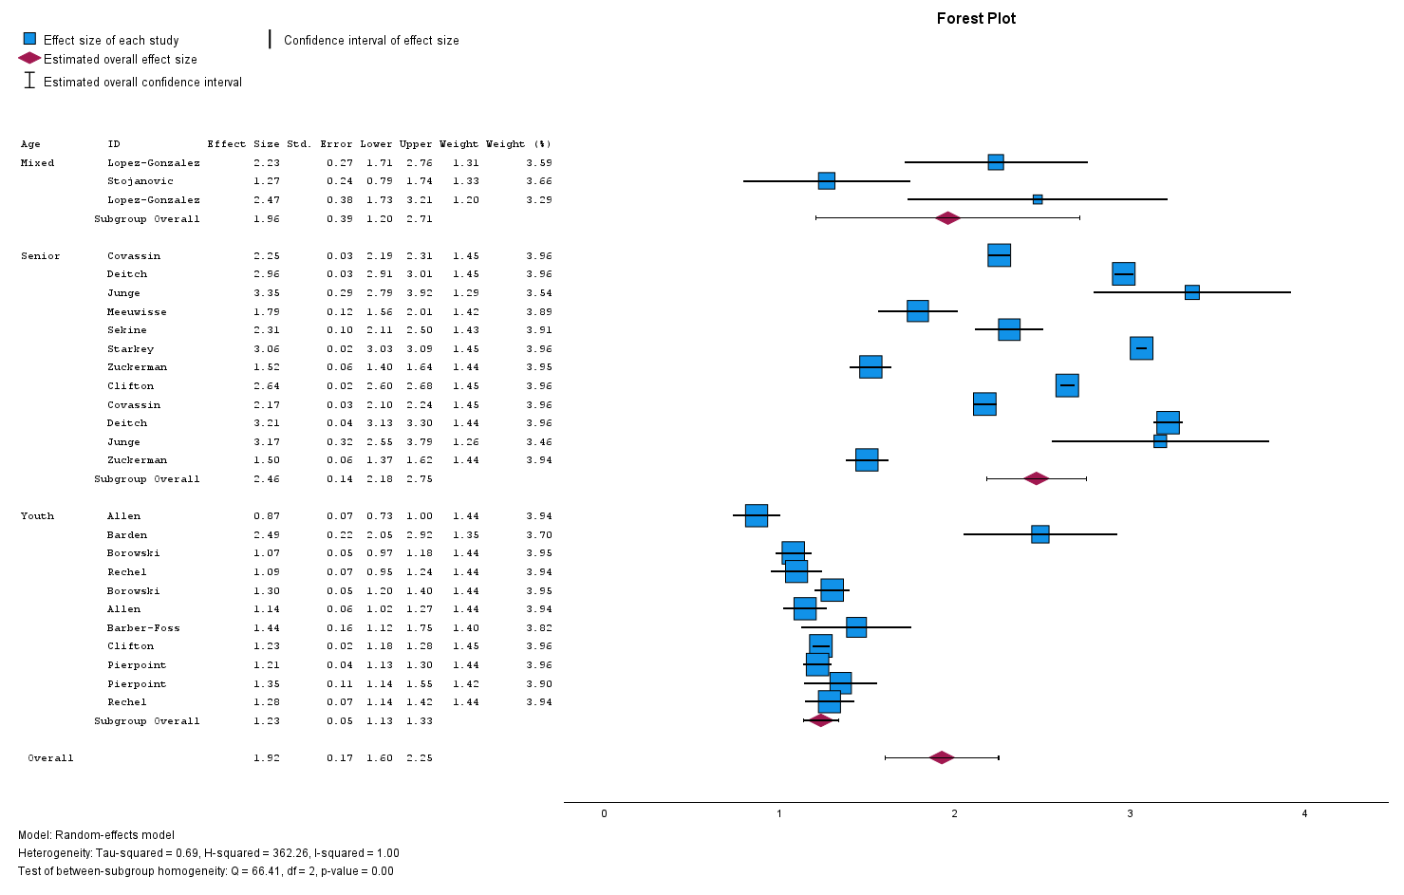
1.3 Sub-group: Sex
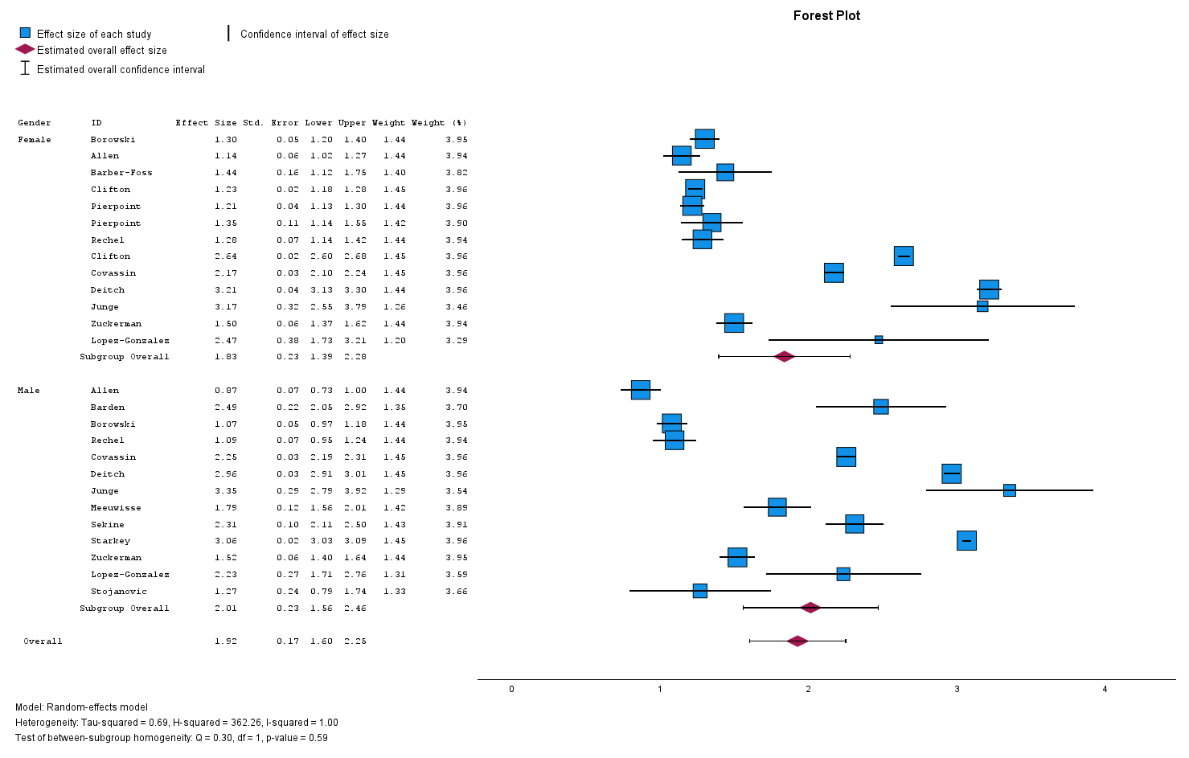

2.1 Training TL/1000AE
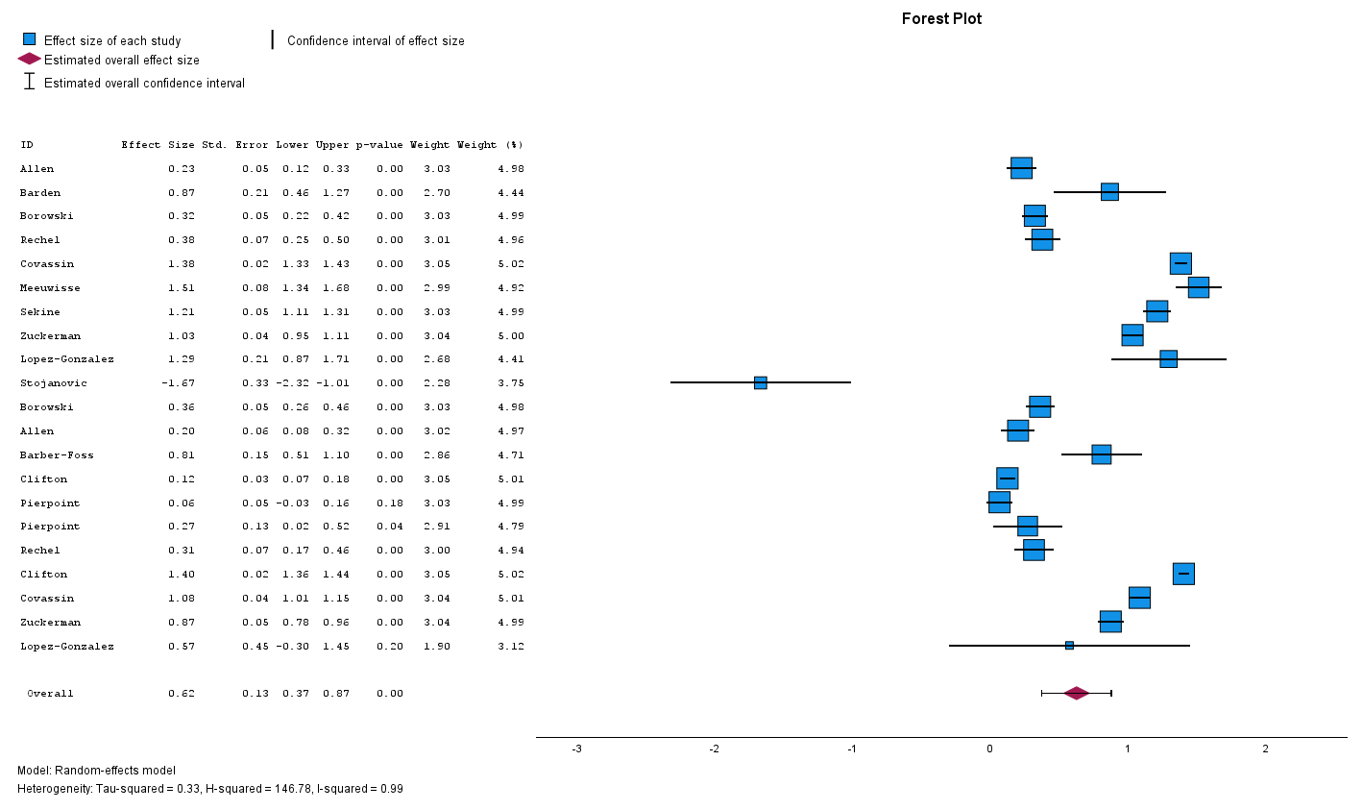
2.2 Sub-group: Playing-age group
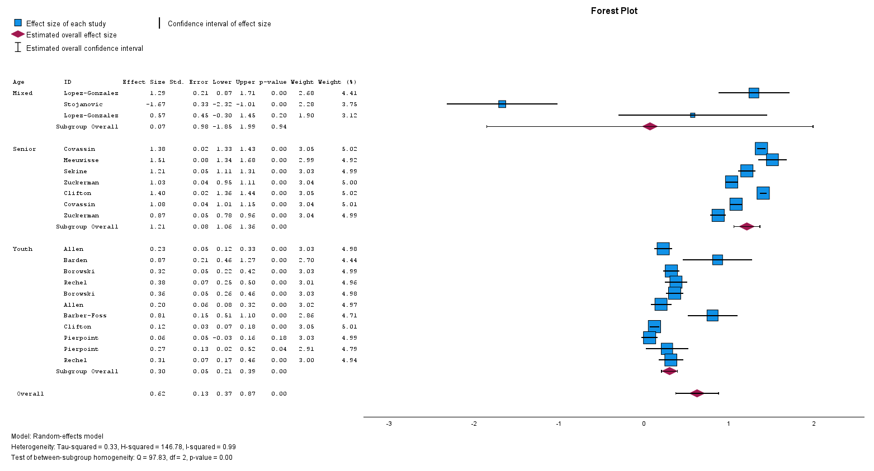
2.3 Sub-group: Sex
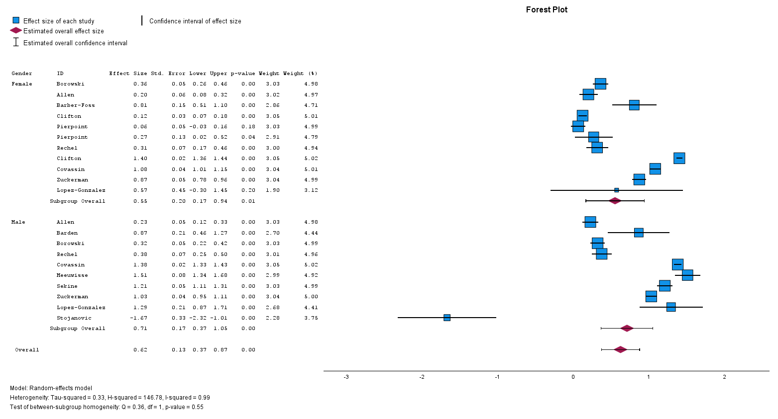

3.1 Match TL/1000h
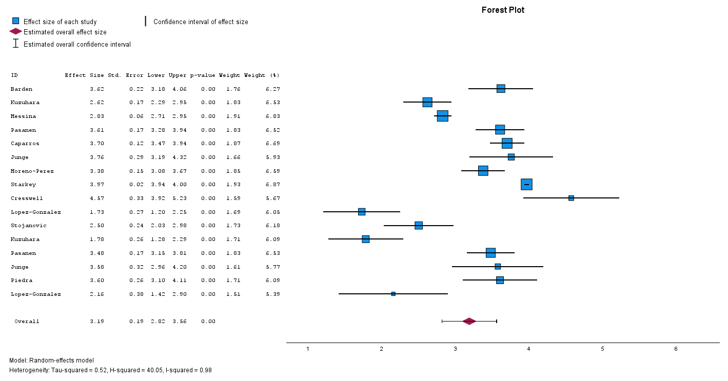
3.2 Sub-group: Playing-age Group
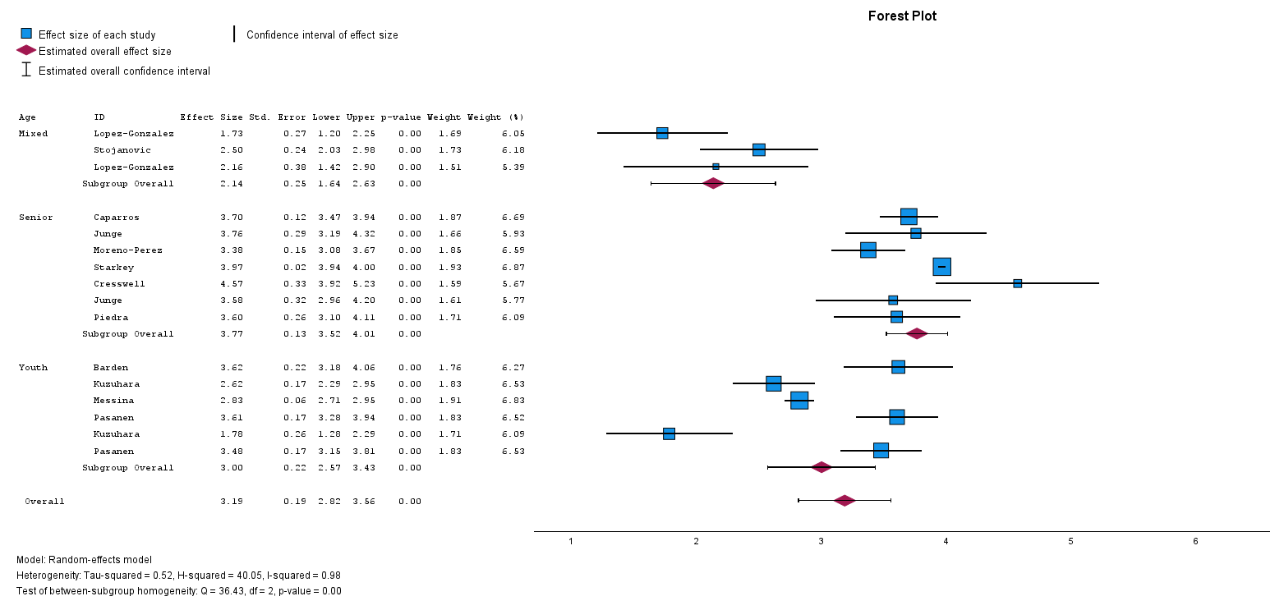
3.3 Sub-group: Sex
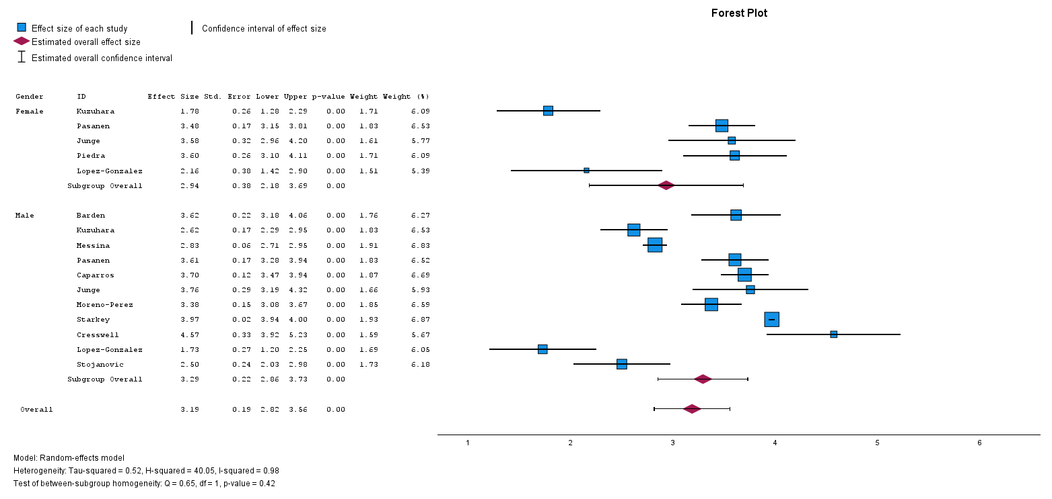

4.1 Training TL/1000h
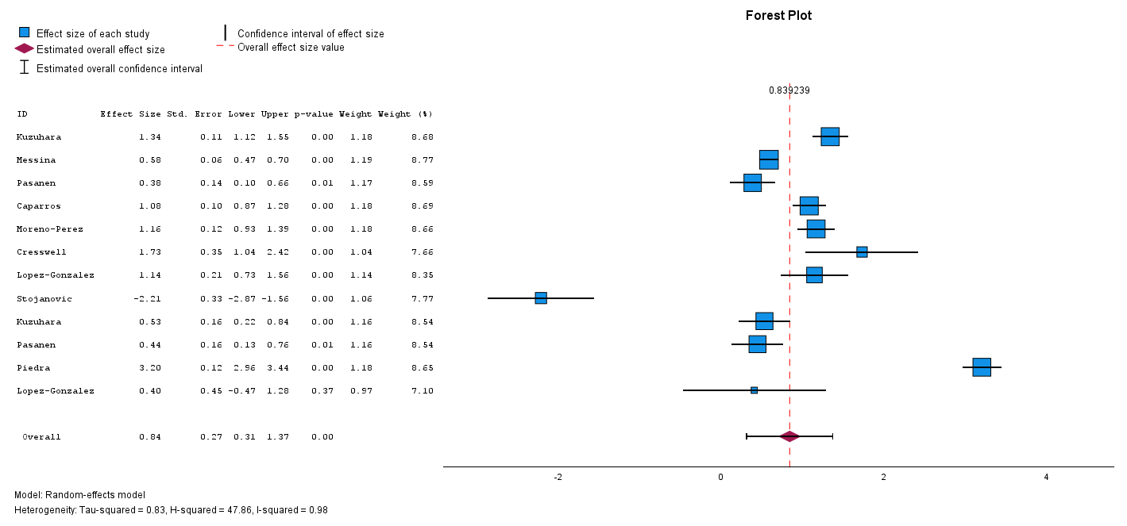
4.2 Sub-group: Playing-age Group
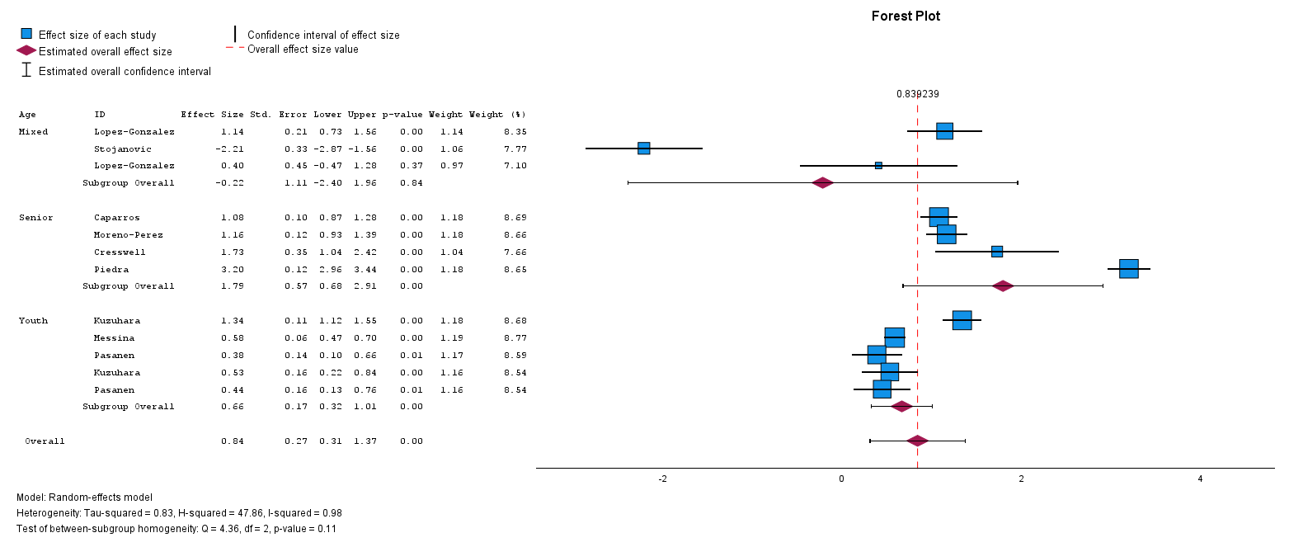
4.3 Sub-group: Sex
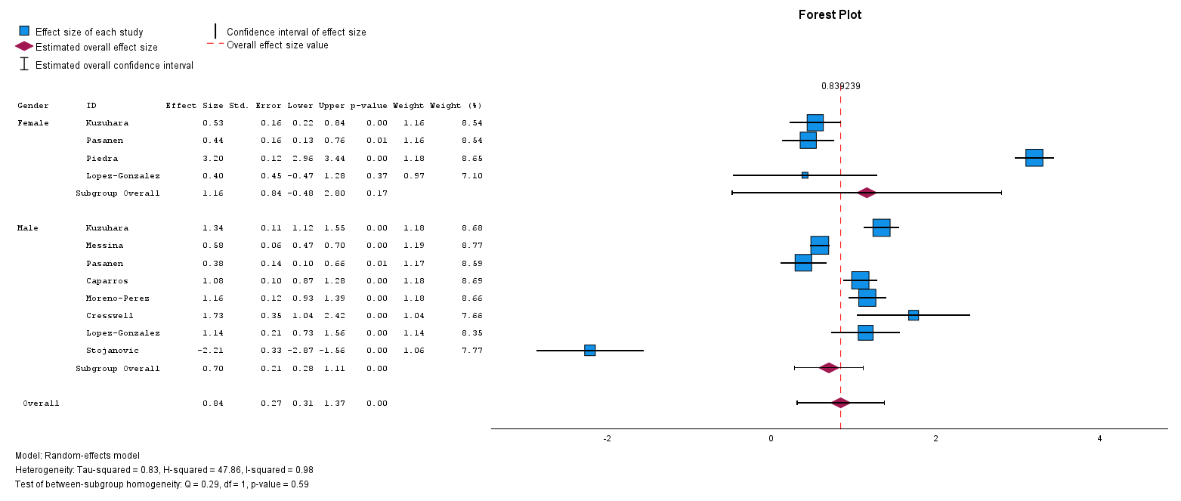

5.1 Match MA/1000AE
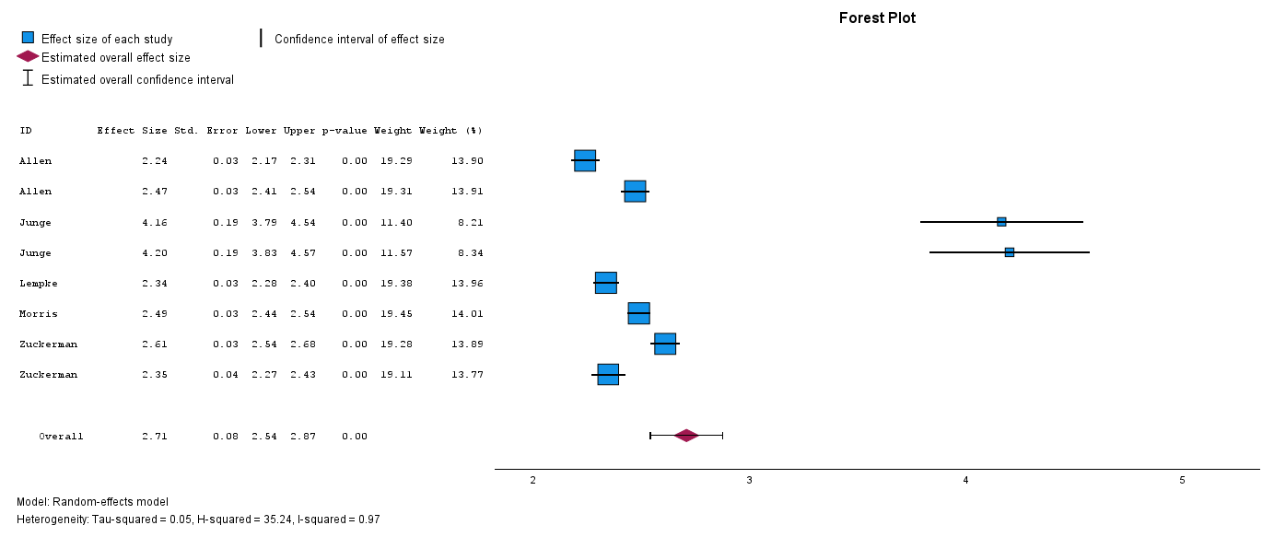
5.2 Sub-group: Sex
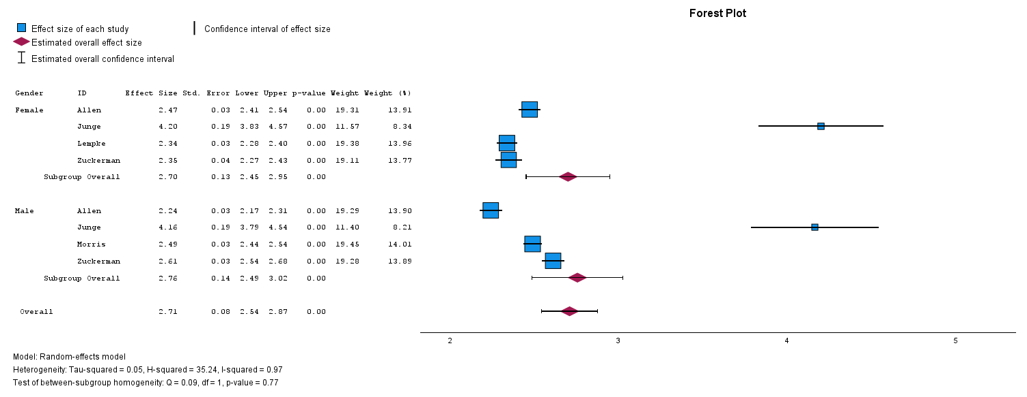
6.1 Match MA/1000h
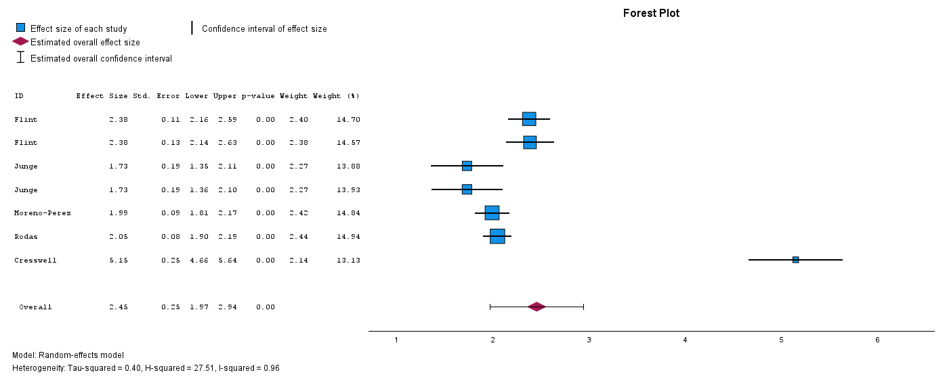
7.1. Training MA/1000AE
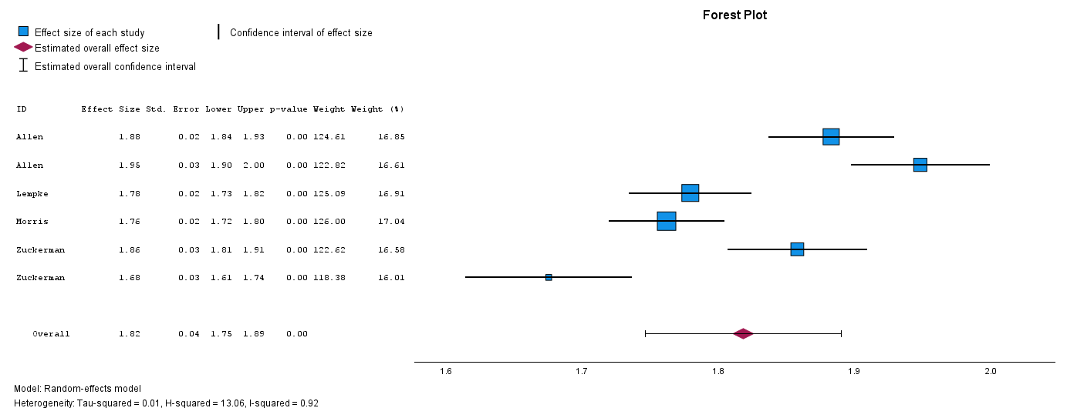
7.1 Subgroup: Sex
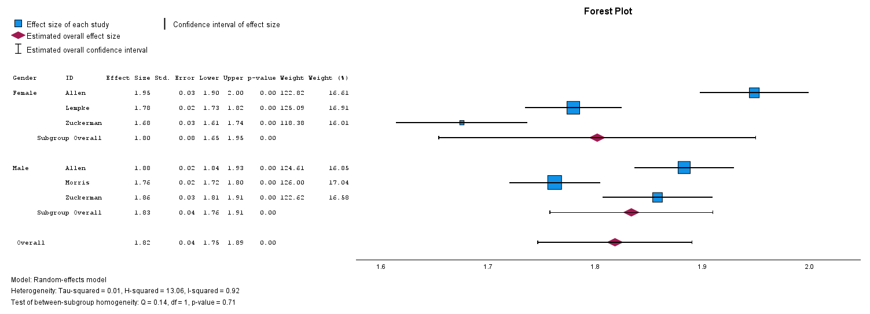
8. Training MA/1000h
